Московский государственный технический университет им. Н.Э. Баумана

Факультет «Информатика и системы управления»

Кафедра «Системы обработки информации и управления»



**Лабораторная работа № 2**

**«Цифро-аналоговые преобразователи»**

**ИСПОЛНИТЕЛЬ:**

студент ИУ5-72Б

Савченко Григорий

**ПРЕПОДАВАТЕЛЬ:**

Нестеров Ю.Г.

Подпись:

14.10.2021

Москва, 2021

1. **Входные данные**

Вариант 19

|  |  |  |  |  |
| --- | --- | --- | --- | --- |
| **N** | **U0, В** | **Umax, В** | **весов.** | **лестничн.** |
| 7 | 15 | 6 | рис.1 | рис.6 + рис.8 |

1. **ЦАД с весовыми резисторами**

Пусть

$$R_{1}=1 кОм$$

Тогда

$$R_{2}=2∙R_{1}=2 кОм$$

$$R_{3}=2∙R_{2}=4 кОм$$

$$R_{4}=2∙R_{3}=8 кОм$$

$$R_{5}=2∙R_{4}=16 кОм$$

$$R_{6}=2∙R_{5}=32 кОм$$

$$R_{7}=2∙R_{6}=64 кОм$$

Сопротивление резистора $R_{0}$ должно быть много больше сопротивления резистора $R_{7}$. Возьмем сопротивление $R_{0}=1 МОм$

Сопротивление резисторов буферного каскада $R_{8}$ и $R_{9}$ выберем таким образом, чтобы операционный усилитель не входил в насыщение, а выходное напряжение не превышало $U_{max}=6 В$.

При всех замкнутых ключах на входе операционного усилителя будет самое высокое напряжение. Рассчитаем напряжение при всех замкнутых ключах.

$$I_{0}=\frac{U_{0}}{\sum_{i=0}^{7}{R_{i}}}=1,333∙{10}^{-5}$$

$$U_{вх}=I_{0}∙\sum_{i=1}^{7}{R_{i}=}126000∙1,333∙{10}^{-5}=1,67985 В$$

Рассчитаем делитель напряжение на операционном усилителе.

$$U_{вых}=U_{вх}\left(1+\frac{R_{8}}{R_{9}}\right)=>\frac{R_{8}}{R_{9}}=\frac{U_{вых}}{U_{вх}}-1=\frac{6}{1.67985}-1=2,572$$

Выбрано значение $R_{8}=2,572 кОм,R_{9}=1 кОм.$

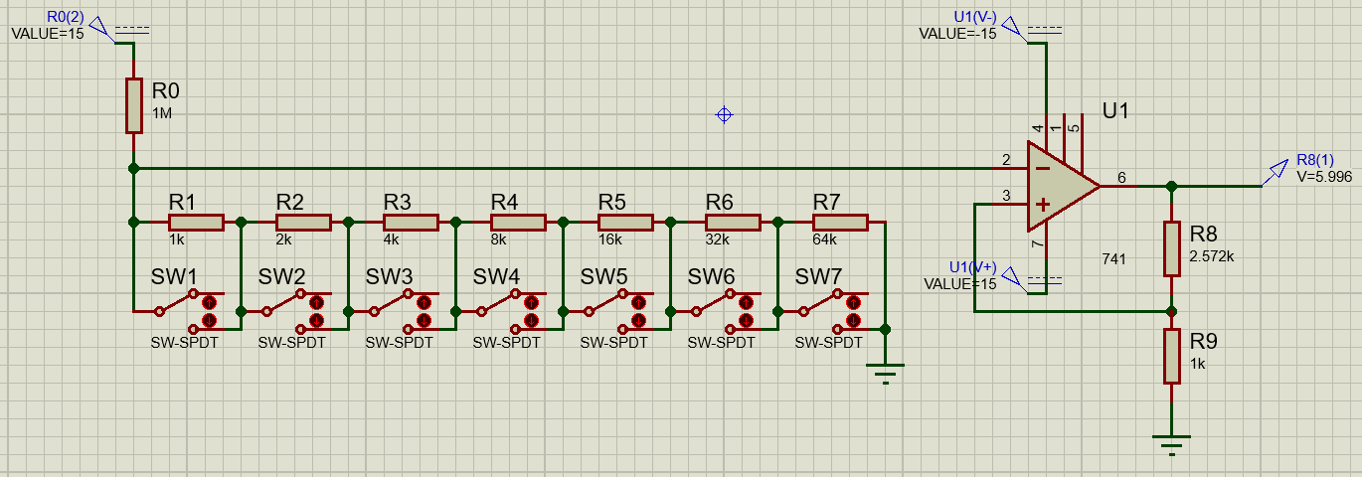

|  |  |  |  |  |  |  |  |  |
| --- | --- | --- | --- | --- | --- | --- | --- | --- |
| Код | Разряды | | | | | | | Uвых, В |
| 0 | 0 | 0 | 0 | 0 | 0 | 0 | 0 | 5,9960 |
| 1 | 0 | 0 | 0 | 0 | 0 | 0 | 1 | 5,9228 |
| 2 | 0 | 0 | 0 | 0 | 0 | 1 | 0 | 5,8817 |
| 3 | 0 | 0 | 0 | 0 | 0 | 1 | 1 | 5,8406 |
| 4 | 0 | 0 | 0 | 0 | 1 | 0 | 0 | 5,7993 |
| 5 | 0 | 0 | 0 | 0 | 1 | 0 | 1 | 5,7580 |
| 6 | 0 | 0 | 0 | 0 | 1 | 1 | 0 | 5,7166 |
| 7 | 0 | 0 | 0 | 0 | 1 | 1 | 1 | 5,6751 |
| 8 | 0 | 0 | 0 | 1 | 0 | 0 | 0 | 5,6335 |
| 9 | 0 | 0 | 0 | 1 | 0 | 0 | 1 | 5,5918 |
| 10 | 0 | 0 | 0 | 1 | 0 | 1 | 0 | 5,5500 |
| 11 | 0 | 0 | 0 | 1 | 0 | 1 | 1 | 5,5081 |
| 12 | 0 | 0 | 0 | 1 | 1 | 0 | 0 | 5,4662 |
| 13 | 0 | 0 | 0 | 1 | 1 | 0 | 1 | 5,4241 |
| 14 | 0 | 0 | 0 | 1 | 1 | 1 | 0 | 5,3820 |
| 15 | 0 | 0 | 0 | 1 | 1 | 1 | 1 | 5,3397 |
| 16 | 0 | 0 | 1 | 0 | 0 | 0 | 0 | 5,2974 |
| 17 | 0 | 0 | 1 | 0 | 0 | 0 | 1 | 5,2550 |
| 18 | 0 | 0 | 1 | 0 | 0 | 1 | 0 | 5,2125 |
| 19 | 0 | 0 | 1 | 0 | 0 | 1 | 1 | 5,1699 |
| 20 | 0 | 0 | 1 | 0 | 1 | 0 | 0 | 5,1272 |
| 21 | 0 | 0 | 1 | 0 | 1 | 0 | 1 | 5,0844 |
| 22 | 0 | 0 | 1 | 0 | 1 | 1 | 0 | 5,0415 |
| 23 | 0 | 0 | 1 | 0 | 1 | 1 | 1 | 4,9986 |
| 24 | 0 | 0 | 1 | 1 | 0 | 0 | 0 | 4,9555 |
| 25 | 0 | 0 | 1 | 1 | 0 | 0 | 1 | 4,9123 |
| 26 | 0 | 0 | 1 | 1 | 0 | 1 | 0 | 4,8691 |
| 27 | 0 | 0 | 1 | 1 | 0 | 1 | 1 | 4,8257 |
| 28 | 0 | 0 | 1 | 1 | 1 | 0 | 0 | 4,7822 |
| 29 | 0 | 0 | 1 | 1 | 1 | 0 | 1 | 4,7387 |
| 30 | 0 | 0 | 1 | 1 | 1 | 1 | 0 | 4,6951 |
| 31 | 0 | 0 | 1 | 1 | 1 | 1 | 1 | 4,6513 |
| 32 | 0 | 1 | 0 | 0 | 0 | 0 | 0 | 4,6075 |
| 33 | 0 | 1 | 0 | 0 | 0 | 0 | 1 | 4,5635 |
| 34 | 0 | 1 | 0 | 0 | 0 | 1 | 0 | 4,5198 |
| 35 | 0 | 1 | 0 | 0 | 0 | 1 | 1 | 4,4757 |
| 36 | 0 | 1 | 0 | 0 | 1 | 0 | 0 | 4,4315 |
| 37 | 0 | 1 | 0 | 0 | 1 | 0 | 1 | 4,3872 |
| 38 | 0 | 1 | 0 | 0 | 1 | 1 | 0 | 4,3427 |
| 39 | 0 | 1 | 0 | 0 | 1 | 1 | 1 | 4,2982 |
| 40 | 0 | 1 | 0 | 1 | 0 | 0 | 0 | 4,2536 |
| 41 | 0 | 1 | 0 | 1 | 0 | 0 | 1 | 4,2089 |
| 42 | 0 | 1 | 0 | 1 | 0 | 1 | 0 | 4,1641 |
| 43 | 0 | 1 | 0 | 1 | 0 | 1 | 1 | 4,1176 |
| 44 | 0 | 1 | 0 | 1 | 1 | 0 | 0 | 4,0741 |
| 45 | 0 | 1 | 0 | 1 | 1 | 0 | 1 | 4,0290 |
| 46 | 0 | 1 | 0 | 1 | 1 | 1 | 0 | 3,9838 |
| 47 | 0 | 1 | 0 | 1 | 1 | 1 | 1 | 3,9385 |
| 48 | 0 | 1 | 1 | 0 | 0 | 0 | 0 | 3,8931 |
| 49 | 0 | 1 | 1 | 0 | 0 | 0 | 1 | 3,8475 |
| 50 | 0 | 1 | 1 | 0 | 0 | 1 | 0 | 3,8020 |
| 51 | 0 | 1 | 1 | 0 | 0 | 1 | 1 | 3,7563 |
| 52 | 0 | 1 | 1 | 0 | 1 | 0 | 0 | 3,7104 |
| 53 | 0 | 1 | 1 | 0 | 1 | 0 | 1 | 3,6645 |
| 54 | 0 | 1 | 1 | 0 | 1 | 1 | 0 | 3,6185 |
| 55 | 0 | 1 | 1 | 0 | 1 | 1 | 1 | 3,5723 |
| 56 | 0 | 1 | 1 | 1 | 0 | 0 | 0 | 3,5261 |
| 57 | 0 | 1 | 1 | 1 | 0 | 0 | 1 | 3,4798 |
| 58 | 0 | 1 | 1 | 1 | 0 | 1 | 0 | 3,4334 |
| 59 | 0 | 1 | 1 | 1 | 0 | 1 | 1 | 3,3868 |
| 60 | 0 | 1 | 1 | 1 | 1 | 0 | 0 | 3,3401 |
| 61 | 0 | 1 | 1 | 1 | 1 | 0 | 1 | 3,2934 |
| 62 | 0 | 1 | 1 | 1 | 1 | 1 | 0 | 3,2465 |
| 63 | 0 | 1 | 1 | 1 | 1 | 1 | 1 | 3,1995 |
| 64 | 1 | 0 | 0 | 0 | 0 | 0 | 0 | 3,1524 |
| 65 | 1 | 0 | 0 | 0 | 0 | 0 | 1 | 3,1052 |
| 66 | 1 | 0 | 0 | 0 | 0 | 1 | 0 | 3,0580 |
| 67 | 1 | 0 | 0 | 0 | 0 | 1 | 1 | 3,0106 |
| 68 | 1 | 0 | 0 | 0 | 1 | 0 | 0 | 2,9632 |
| 69 | 1 | 0 | 0 | 0 | 1 | 0 | 1 | 2,9156 |
| 70 | 1 | 0 | 0 | 0 | 1 | 1 | 0 | 2,8680 |
| 71 | 1 | 0 | 0 | 0 | 1 | 1 | 1 | 2,8203 |
| 72 | 1 | 0 | 0 | 1 | 0 | 0 | 0 | 2,7725 |
| 73 | 1 | 0 | 0 | 1 | 0 | 0 | 1 | 2,7246 |
| 74 | 1 | 0 | 0 | 1 | 0 | 1 | 0 | 2,6766 |
| 75 | 1 | 0 | 0 | 1 | 0 | 1 | 1 | 2,6285 |
| 76 | 1 | 0 | 0 | 1 | 1 | 0 | 0 | 2,5804 |
| 77 | 1 | 0 | 0 | 1 | 1 | 0 | 1 | 2,5321 |
| 78 | 1 | 0 | 0 | 1 | 1 | 1 | 0 | 2,4838 |
| 79 | 1 | 0 | 0 | 1 | 1 | 1 | 1 | 2,4353 |
| 80 | 1 | 0 | 1 | 0 | 0 | 0 | 0 | 2,3868 |
| 81 | 1 | 0 | 1 | 0 | 0 | 0 | 1 | 2,3382 |
| 82 | 1 | 0 | 1 | 0 | 0 | 1 | 0 | 2,2895 |
| 83 | 1 | 0 | 1 | 0 | 0 | 1 | 1 | 2,2407 |
| 84 | 1 | 0 | 1 | 0 | 1 | 0 | 0 | 2,1918 |
| 85 | 1 | 0 | 1 | 0 | 1 | 0 | 1 | 2,1428 |
| 86 | 1 | 0 | 1 | 0 | 1 | 1 | 0 | 2,0937 |
| 87 | 1 | 0 | 1 | 0 | 1 | 1 | 1 | 2,0445 |
| 88 | 1 | 0 | 1 | 1 | 0 | 0 | 0 | 1,9952 |
| 89 | 1 | 0 | 1 | 1 | 0 | 0 | 1 | 1,9458 |
| 90 | 1 | 0 | 1 | 1 | 0 | 1 | 0 | 1,8963 |
| 91 | 1 | 0 | 1 | 1 | 0 | 1 | 1 | 1,8467 |
| 92 | 1 | 0 | 1 | 1 | 1 | 0 | 0 | 1,7971 |
| 93 | 1 | 0 | 1 | 1 | 1 | 0 | 1 | 1,7473 |
| 94 | 1 | 0 | 1 | 1 | 1 | 1 | 0 | 1,6974 |
| 95 | 1 | 0 | 1 | 1 | 1 | 1 | 1 | 1,6475 |
| 96 | 1 | 1 | 0 | 0 | 0 | 0 | 0 | 1,5978 |
| 97 | 1 | 1 | 0 | 0 | 0 | 0 | 1 | 1,5476 |
| 98 | 1 | 1 | 0 | 0 | 0 | 1 | 0 | 1,4973 |
| 99 | 1 | 1 | 0 | 0 | 0 | 1 | 1 | 1,4470 |
| 100 | 1 | 1 | 0 | 0 | 1 | 0 | 0 | 1,3966 |
| 101 | 1 | 1 | 0 | 0 | 1 | 0 | 1 | 1,3460 |
| 102 | 1 | 1 | 0 | 0 | 1 | 1 | 0 | 1,2954 |
| 103 | 1 | 1 | 0 | 0 | 1 | 1 | 1 | 1,2446 |
| 104 | 1 | 1 | 0 | 1 | 0 | 0 | 0 | 1,1938 |
| 105 | 1 | 1 | 0 | 1 | 0 | 0 | 1 | 1,1413 |
| 106 | 1 | 1 | 0 | 1 | 0 | 1 | 0 | 1,0918 |
| 107 | 1 | 1 | 0 | 1 | 0 | 1 | 1 | 1,0407 |
| 108 | 1 | 1 | 0 | 1 | 1 | 0 | 0 | 0,9894 |
| 109 | 1 | 1 | 0 | 1 | 1 | 0 | 1 | 0,9381 |
| 110 | 1 | 1 | 0 | 1 | 1 | 1 | 0 | 0,8866 |
| 111 | 1 | 1 | 0 | 1 | 1 | 1 | 1 | 0,8351 |
| 112 | 1 | 1 | 1 | 0 | 0 | 0 | 0 | 0,7835 |
| 113 | 1 | 1 | 1 | 0 | 0 | 0 | 1 | 0,7318 |
| 114 | 1 | 1 | 1 | 0 | 0 | 1 | 0 | 0,6799 |
| 115 | 1 | 1 | 1 | 0 | 0 | 1 | 1 | 0,6280 |
| 116 | 1 | 1 | 1 | 0 | 1 | 0 | 0 | 0,5759 |
| 117 | 1 | 1 | 1 | 0 | 1 | 0 | 1 | 0,5238 |
| 118 | 1 | 1 | 1 | 0 | 1 | 1 | 0 | 0,4715 |
| 119 | 1 | 1 | 1 | 0 | 1 | 1 | 1 | 0,4191 |
| 120 | 1 | 1 | 1 | 1 | 0 | 0 | 0 | 0,3668 |
| 121 | 1 | 1 | 1 | 1 | 0 | 0 | 1 | 0,3141 |
| 122 | 1 | 1 | 1 | 1 | 0 | 1 | 0 | 0,2614 |
| 123 | 1 | 1 | 1 | 1 | 0 | 1 | 1 | 0,2086 |
| 124 | 1 | 1 | 1 | 1 | 1 | 0 | 0 | 0,1558 |
| 125 | 1 | 1 | 1 | 1 | 1 | 0 | 1 | 0,1028 |
| 126 | 1 | 1 | 1 | 1 | 1 | 1 | 0 | 0,0497 |
| 127 | 1 | 1 | 1 | 1 | 1 | 1 | 1 | -0,0035 |

График зависимости выходного сигнала ЦАП с весовыми резисторами от значения цифрового кода:

Схема ЦАП с весовыми резисторами с переключателем с электронным управлением на старшем разряде, собранная в системе Proteus:

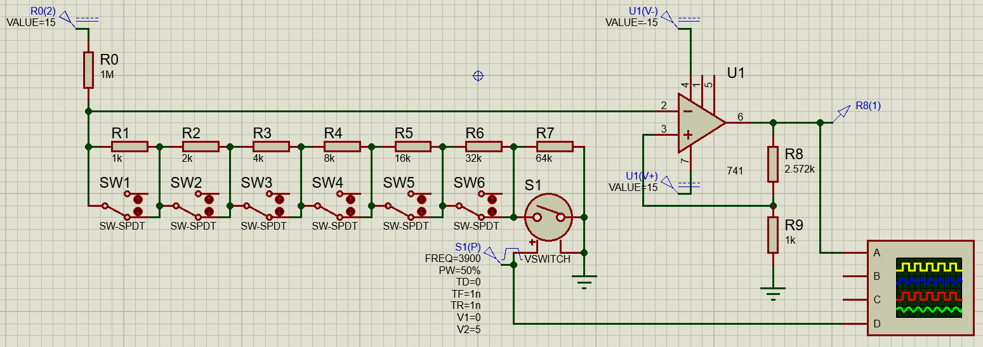

Изменяя частоту меандра, определим максимальную рабочую частоту   
исследуемого ЦАП. Находим погрешность 10% между полупериодами входного и выходного сигналов, получаем максимальную рабочую частоту $f_{\max_{вес}}=3,9 кГц.$

$$\frac{T_{вх}/2-T_{вых}/2}{T_{вх}/2}*100\%=\frac{128 мкс-115,50 мкс}{128 мкс}*100\%=10\%$$

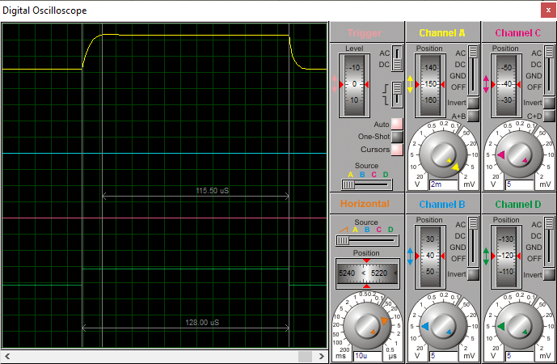

1. **ЦАП лестничного типа**

Пусть

$$R_{9}=1 кОм$$

Тогда

$${R_{9}=R}_{10}=R_{11}=R_{12}=R_{13}=R_{14}=R_{15}=1 кОм$$

$$\frac{R_{9}}{2}=R_{1}=R_{2}=R_{3}=R_{4}=R_{5}=R_{6}=R_{7}=R_{8}=500$$

Пусть

$$R_{16}=R_{17}=R_{18}=R_{19}=R_{20}=R_{21}=R_{22}=1 кОм$$

Максимальное напряжение на входе операционного усилителя 2,316 В

Рассчитаем делитель напряжения на резисторах $R_{23}и R_{24}$

$$U_{вых}=U_{вх}\left(1+\frac{R_{23}}{R_{24}}\right)=>\frac{R_{23}}{R_{24}}=\frac{U_{вых}}{U_{вх}}-1=\frac{6}{2,316}-1=1,59$$

Выбрано значение $R_{23}=1,59 кОм,R_{24}=1 кОм.$

Схема ЦАП лестничного типа, собранная в системе Proteus:

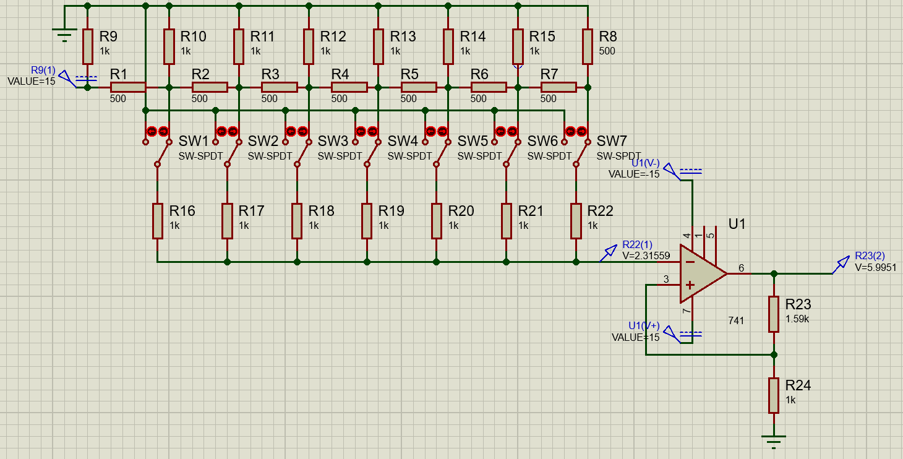

Зависимость выходного сигнала ЦАП лестничного типа от значения цифрового кода:

|  |  |  |  |  |  |  |  |  |
| --- | --- | --- | --- | --- | --- | --- | --- | --- |
| Код | Разряды | | | | | | | Uвых, В |
| 0 | 0 | 0 | 0 | 0 | 0 | 0 | 0 | -0,0027 |
| 1 | 0 | 0 | 0 | 0 | 0 | 0 | 1 | 0,0446 |
| 2 | 0 | 0 | 0 | 0 | 0 | 1 | 0 | 0,0918 |
| 3 | 0 | 0 | 0 | 0 | 0 | 1 | 1 | 0,139 |
| 4 | 0 | 0 | 0 | 0 | 1 | 0 | 0 | 0,1863 |
| 5 | 0 | 0 | 0 | 0 | 1 | 0 | 1 | 0,2335 |
| 6 | 0 | 0 | 0 | 0 | 1 | 1 | 0 | 0,2807 |
| 7 | 0 | 0 | 0 | 0 | 1 | 1 | 1 | 0,3279 |
| 8 | 0 | 0 | 0 | 1 | 0 | 0 | 0 | 0,3752 |
| 9 | 0 | 0 | 0 | 1 | 0 | 0 | 1 | 0,4224 |
| 10 | 0 | 0 | 0 | 1 | 0 | 1 | 0 | 0,4696 |
| 11 | 0 | 0 | 0 | 1 | 0 | 1 | 1 | 0,5168 |
| 12 | 0 | 0 | 0 | 1 | 1 | 0 | 0 | 0,5641 |
| 13 | 0 | 0 | 0 | 1 | 1 | 0 | 1 | 0,6113 |
| 14 | 0 | 0 | 0 | 1 | 1 | 1 | 0 | 0,6585 |
| 15 | 0 | 0 | 0 | 1 | 1 | 1 | 1 | 0,7058 |
| 16 | 0 | 0 | 1 | 0 | 0 | 0 | 0 | 0,753 |
| 17 | 0 | 0 | 1 | 0 | 0 | 0 | 1 | 0,8002 |
| 18 | 0 | 0 | 1 | 0 | 0 | 1 | 0 | 0,8474 |
| 19 | 0 | 0 | 1 | 0 | 0 | 1 | 1 | 0,8947 |
| 20 | 0 | 0 | 1 | 0 | 1 | 0 | 0 | 0,9419 |
| 21 | 0 | 0 | 1 | 0 | 1 | 0 | 1 | 0,9891 |
| 22 | 0 | 0 | 1 | 0 | 1 | 1 | 0 | 1,0363 |
| 23 | 0 | 0 | 1 | 0 | 1 | 1 | 1 | 1,0836 |
| 24 | 0 | 0 | 1 | 1 | 0 | 0 | 0 | 1,1308 |
| 25 | 0 | 0 | 1 | 1 | 0 | 0 | 1 | 1,178 |
| 26 | 0 | 0 | 1 | 1 | 0 | 1 | 0 | 1,2252 |
| 27 | 0 | 0 | 1 | 1 | 0 | 1 | 1 | 1,2725 |
| 28 | 0 | 0 | 1 | 1 | 1 | 0 | 0 | 1,3197 |
| 29 | 0 | 0 | 1 | 1 | 1 | 0 | 1 | 1,3669 |
| 30 | 0 | 0 | 1 | 1 | 1 | 1 | 0 | 1,4142 |
| 31 | 0 | 0 | 1 | 1 | 1 | 1 | 1 | 1,4614 |
| 32 | 0 | 1 | 0 | 0 | 0 | 0 | 0 | 1,5086 |
| 33 | 0 | 1 | 0 | 0 | 0 | 0 | 1 | 1,5558 |
| 34 | 0 | 1 | 0 | 0 | 0 | 1 | 0 | 1,6031 |
| 35 | 0 | 1 | 0 | 0 | 0 | 1 | 1 | 1,6503 |
| 36 | 0 | 1 | 0 | 0 | 1 | 0 | 0 | 1,6975 |
| 37 | 0 | 1 | 0 | 0 | 1 | 0 | 1 | 1,7447 |
| 38 | 0 | 1 | 0 | 0 | 1 | 1 | 0 | 1,792 |
| 39 | 0 | 1 | 0 | 0 | 1 | 1 | 1 | 1,8392 |
| 40 | 0 | 1 | 0 | 1 | 0 | 0 | 0 | 1,8864 |
| 41 | 0 | 1 | 0 | 1 | 0 | 0 | 1 | 1,9336 |
| 42 | 0 | 1 | 0 | 1 | 0 | 1 | 0 | 1,9809 |
| 43 | 0 | 1 | 0 | 1 | 0 | 1 | 1 | 2,0281 |
| 44 | 0 | 1 | 0 | 1 | 1 | 0 | 0 | 2,0753 |
| 45 | 0 | 1 | 0 | 1 | 1 | 0 | 1 | 2,1226 |
| 46 | 0 | 1 | 0 | 1 | 1 | 1 | 0 | 2,1698 |
| 47 | 0 | 1 | 0 | 1 | 1 | 1 | 1 | 2,217 |
| 48 | 0 | 1 | 1 | 0 | 0 | 0 | 0 | 2,2642 |
| 49 | 0 | 1 | 1 | 0 | 0 | 0 | 1 | 2,3115 |
| 50 | 0 | 1 | 1 | 0 | 0 | 1 | 0 | 2,3587 |
| 51 | 0 | 1 | 1 | 0 | 0 | 1 | 1 | 2,4059 |
| 52 | 0 | 1 | 1 | 0 | 1 | 0 | 0 | 2,4531 |
| 53 | 0 | 1 | 1 | 0 | 1 | 0 | 1 | 2,5004 |
| 54 | 0 | 1 | 1 | 0 | 1 | 1 | 0 | 2,5476 |
| 55 | 0 | 1 | 1 | 0 | 1 | 1 | 1 | 2,5948 |
| 56 | 0 | 1 | 1 | 1 | 0 | 0 | 0 | 2,642 |
| 57 | 0 | 1 | 1 | 1 | 0 | 0 | 1 | 2,6893 |
| 58 | 0 | 1 | 1 | 1 | 0 | 1 | 0 | 2,7365 |
| 59 | 0 | 1 | 1 | 1 | 0 | 1 | 1 | 2,7837 |
| 60 | 0 | 1 | 1 | 1 | 1 | 0 | 0 | 2,831 |
| 61 | 0 | 1 | 1 | 1 | 1 | 0 | 1 | 2,8782 |
| 62 | 0 | 1 | 1 | 1 | 1 | 1 | 0 | 2,9254 |
| 63 | 0 | 1 | 1 | 1 | 1 | 1 | 1 | 2,9726 |
| 64 | 1 | 0 | 0 | 0 | 0 | 0 | 0 | 3,0199 |
| 65 | 1 | 0 | 0 | 0 | 0 | 0 | 1 | 3,0671 |
| 66 | 1 | 0 | 0 | 0 | 0 | 1 | 0 | 3,1143 |
| 67 | 1 | 0 | 0 | 0 | 0 | 1 | 1 | 3,1615 |
| 68 | 1 | 0 | 0 | 0 | 1 | 0 | 0 | 3,2088 |
| 69 | 1 | 0 | 0 | 0 | 1 | 0 | 1 | 3,256 |
| 70 | 1 | 0 | 0 | 0 | 1 | 1 | 0 | 3,3032 |
| 71 | 1 | 0 | 0 | 0 | 1 | 1 | 1 | 3,3505 |
| 72 | 1 | 0 | 0 | 1 | 0 | 0 | 0 | 3,3977 |
| 73 | 1 | 0 | 0 | 1 | 0 | 0 | 1 | 3,4449 |
| 74 | 1 | 0 | 0 | 1 | 0 | 1 | 0 | 3,4921 |
| 75 | 1 | 0 | 0 | 1 | 0 | 1 | 1 | 3,5394 |
| 76 | 1 | 0 | 0 | 1 | 1 | 0 | 0 | 3,5866 |
| 77 | 1 | 0 | 0 | 1 | 1 | 0 | 1 | 3,6338 |
| 78 | 1 | 0 | 0 | 1 | 1 | 1 | 0 | 3,681 |
| 79 | 1 | 0 | 0 | 1 | 1 | 1 | 1 | 3,7283 |
| 80 | 1 | 0 | 1 | 0 | 0 | 0 | 0 | 3,7755 |
| 81 | 1 | 0 | 1 | 0 | 0 | 0 | 1 | 3,8227 |
| 82 | 1 | 0 | 1 | 0 | 0 | 1 | 0 | 3,8699 |
| 83 | 1 | 0 | 1 | 0 | 0 | 1 | 1 | 3,9172 |
| 84 | 1 | 0 | 1 | 0 | 1 | 0 | 0 | 3,9644 |
| 85 | 1 | 0 | 1 | 0 | 1 | 0 | 1 | 4,0116 |
| 86 | 1 | 0 | 1 | 0 | 1 | 1 | 0 | 4,0589 |
| 87 | 1 | 0 | 1 | 0 | 1 | 1 | 1 | 4,1061 |
| 88 | 1 | 0 | 1 | 1 | 0 | 0 | 0 | 4,1533 |
| 89 | 1 | 0 | 1 | 1 | 0 | 0 | 1 | 4,2005 |
| 90 | 1 | 0 | 1 | 1 | 0 | 1 | 0 | 4,2478 |
| 91 | 1 | 0 | 1 | 1 | 0 | 1 | 1 | 4,295 |
| 92 | 1 | 0 | 1 | 1 | 1 | 0 | 0 | 4,3422 |
| 93 | 1 | 0 | 1 | 1 | 1 | 0 | 1 | 4,3894 |
| 94 | 1 | 0 | 1 | 1 | 1 | 1 | 0 | 4,4367 |
| 95 | 1 | 0 | 1 | 1 | 1 | 1 | 1 | 4,4839 |
| 96 | 1 | 1 | 0 | 0 | 0 | 0 | 0 | 4,5311 |
| 97 | 1 | 1 | 0 | 0 | 0 | 0 | 1 | 4,5783 |
| 98 | 1 | 1 | 0 | 0 | 0 | 1 | 0 | 4,6256 |
| 99 | 1 | 1 | 0 | 0 | 0 | 1 | 1 | 4,6728 |
| 100 | 1 | 1 | 0 | 0 | 1 | 0 | 0 | 4,72 |
| 101 | 1 | 1 | 0 | 0 | 1 | 0 | 1 | 4,7673 |
| 102 | 1 | 1 | 0 | 0 | 1 | 1 | 0 | 4,8145 |
| 103 | 1 | 1 | 0 | 0 | 1 | 1 | 1 | 4,8617 |
| 104 | 1 | 1 | 0 | 1 | 0 | 0 | 0 | 4,9089 |
| 105 | 1 | 1 | 0 | 1 | 0 | 0 | 1 | 4,9562 |
| 106 | 1 | 1 | 0 | 1 | 0 | 1 | 0 | 5,0034 |
| 107 | 1 | 1 | 0 | 1 | 0 | 1 | 1 | 5,0506 |
| 108 | 1 | 1 | 0 | 1 | 1 | 0 | 0 | 5,0978 |
| 109 | 1 | 1 | 0 | 1 | 1 | 0 | 1 | 5,1451 |
| 110 | 1 | 1 | 0 | 1 | 1 | 1 | 0 | 5,1923 |
| 111 | 1 | 1 | 0 | 1 | 1 | 1 | 1 | 5,2395 |
| 112 | 1 | 1 | 1 | 0 | 0 | 0 | 0 | 5,2867 |
| 113 | 1 | 1 | 1 | 0 | 0 | 0 | 1 | 5,334 |
| 114 | 1 | 1 | 1 | 0 | 0 | 1 | 0 | 5,3812 |
| 115 | 1 | 1 | 1 | 0 | 0 | 1 | 1 | 5,4284 |
| 116 | 1 | 1 | 1 | 0 | 1 | 0 | 0 | 5,4757 |
| 117 | 1 | 1 | 1 | 0 | 1 | 0 | 1 | 5,5229 |
| 118 | 1 | 1 | 1 | 0 | 1 | 1 | 0 | 5,5701 |
| 119 | 1 | 1 | 1 | 0 | 1 | 1 | 1 | 5,6173 |
| 120 | 1 | 1 | 1 | 1 | 0 | 0 | 0 | 5,6646 |
| 121 | 1 | 1 | 1 | 1 | 0 | 0 | 1 | 5,7118 |
| 122 | 1 | 1 | 1 | 1 | 0 | 1 | 0 | 5,759 |
| 123 | 1 | 1 | 1 | 1 | 0 | 1 | 1 | 5,8062 |
| 124 | 1 | 1 | 1 | 1 | 1 | 0 | 0 | 5,8535 |
| 125 | 1 | 1 | 1 | 1 | 1 | 0 | 1 | 5,9007 |
| 126 | 1 | 1 | 1 | 1 | 1 | 1 | 0 | 5,9479 |
| 127 | 1 | 1 | 1 | 1 | 1 | 1 | 1 | 5,9951 |

График зависимости выходного сигнала ЦАП лестничного типа от значения цифрового кода:

Схема ЦАП лестничного типа с переключателем с электронным управлением на старшем разряде, собранная в системе Proteus:

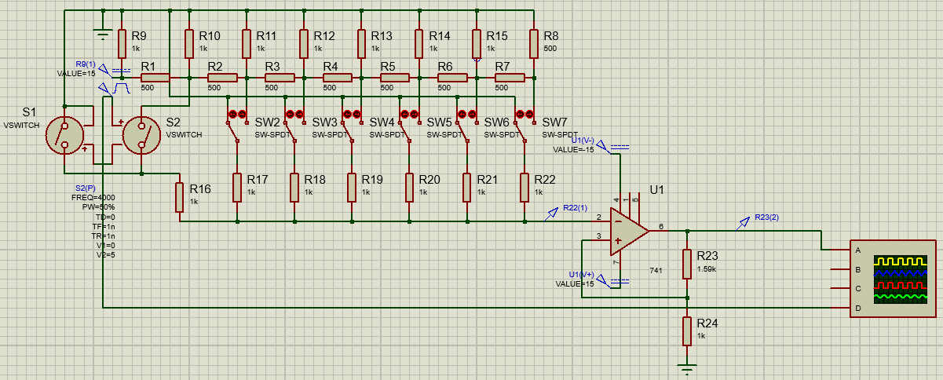

Изменяя частоту меандра, определим максимальную рабочую частоту   
исследуемого ЦАП. Находим погрешность 10% между полупериодами входного и выходного сигналов, получаем максимальную рабочую частоту

